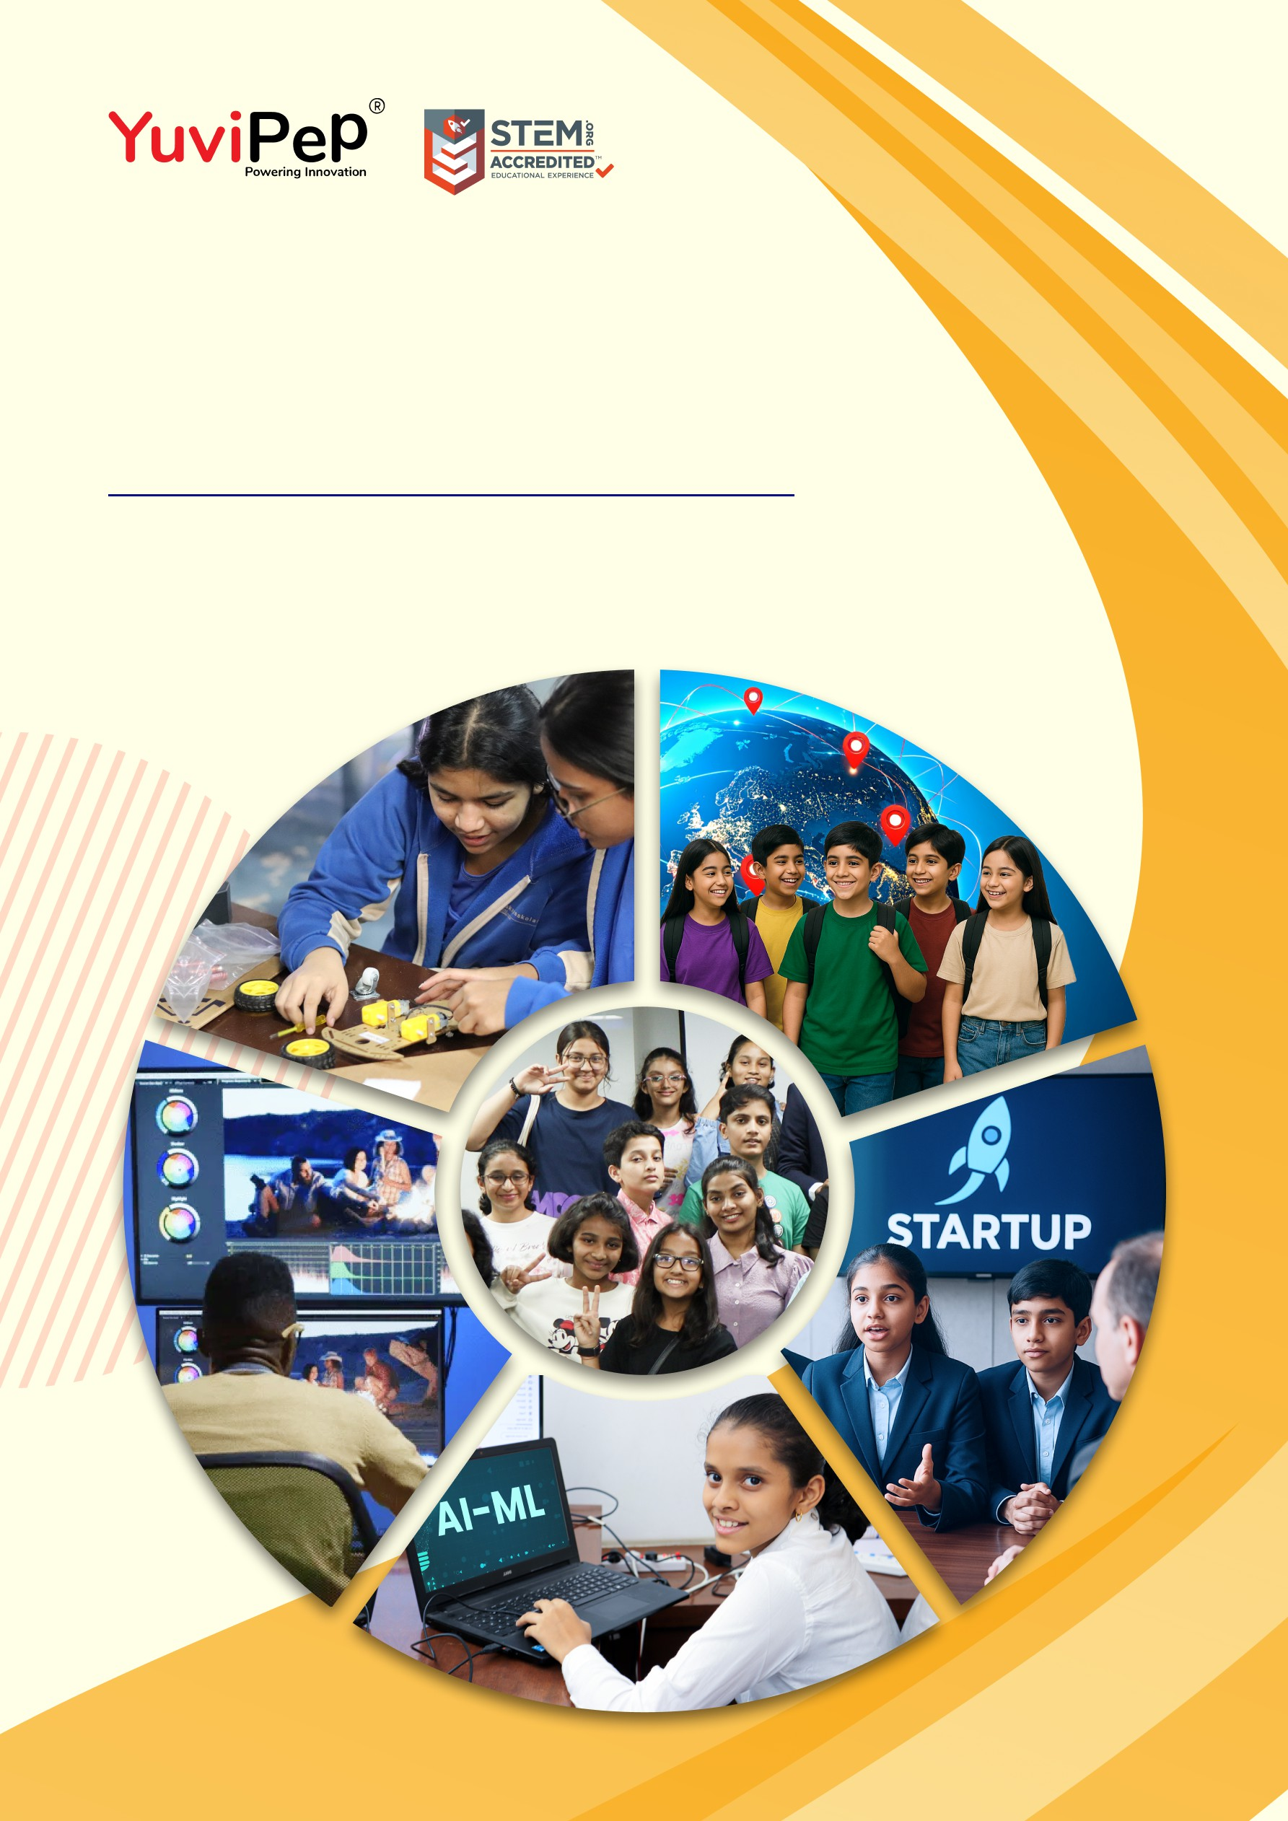

Proposal For

Innovation Lab

<School Name>
Kind Attention: <Name>

Document Version: 1.0
- 1 -
Copyright 2026 YuviPep© All Rights Reserved School Name

About YuviPep’s Innovation Ecosystem

Igniting Innovation, Empowering the Future
YuviPep is a global learning ecosystem that empowers students through experiential education in technology, innovation, design thinking, AI, internships and entrepreneurship. It prepares them to become future-ready creators and problem-solvers.
Our ecosystem is designed to inspire ingenuity and an innovative mindset from an early age. Through engaging programmes such as Academics Beyond Classroom (ABC), Innovation Base Course (IBC), AI G ML, Young Creators Media World, GEN-i Internships and more, we support students from grades 1 to 12 on a journey of self-discovery and skill development. All programmes are aligned with the National Education Policy and the Skill Development Mission and are STEM.org accredited.
YuviPep’s Young Founders Network connects students with industry experts, global platforms, and even early-stage funding to advance their ideas. With partnerships across 200+ institutions and 100+ organisations, we are opening doors to the future.
Learning at YuviPep is hands-on and purposeful. Whether exploring ideas, collaborating on projects, building models, or presenting innovations on global platforms, students gain experiences that last a lifetime.

Our Mission
To build a global educational ecosystem that empowers learners through exploration, innovation and real-world experiences.
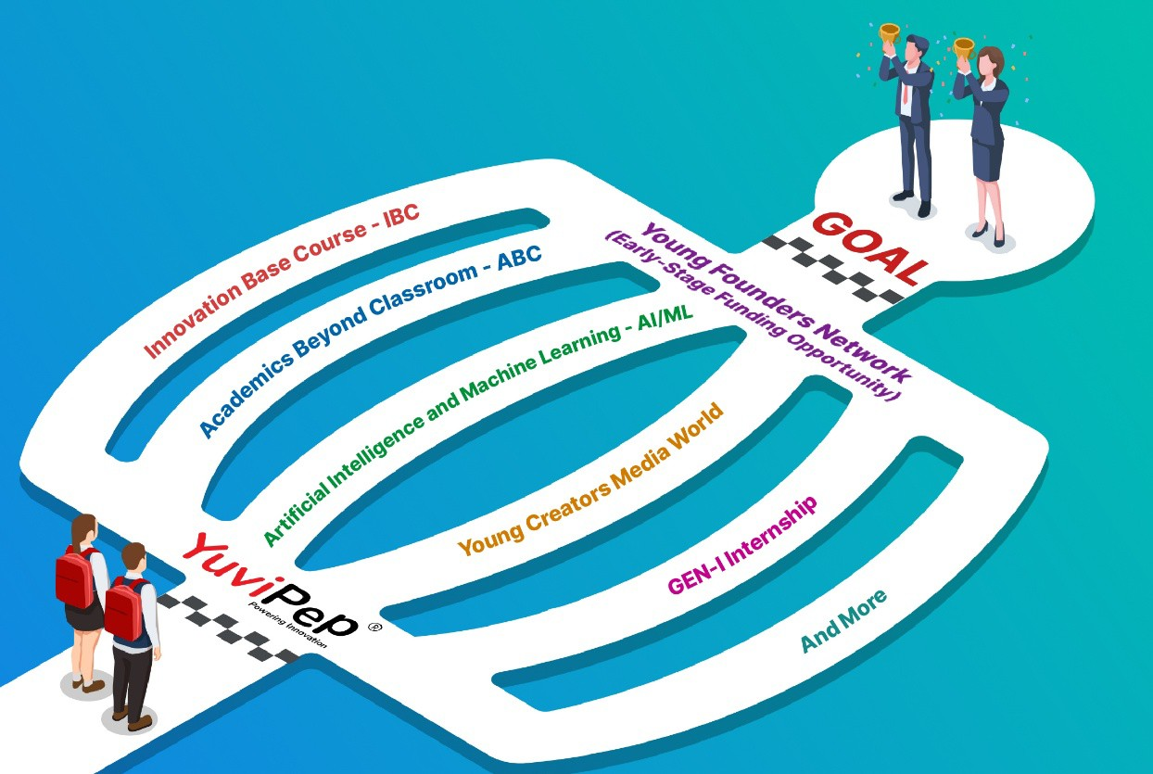

YuviPep Futuristic Innovation Lab
YuviPep’s Futuristic Innovation Lab will provide students with hands-on exposure across YuviPep’s eight core pillars: Practical Science, Design Thinking, Coding, Mechatronics, Automation, Artificial Intelligence, Internet of Things and Robotics. By transforming classrooms into active centres of experimentation, the initiative will promote creativity, strengthen problem-solving abilities and build future-ready skills among students.
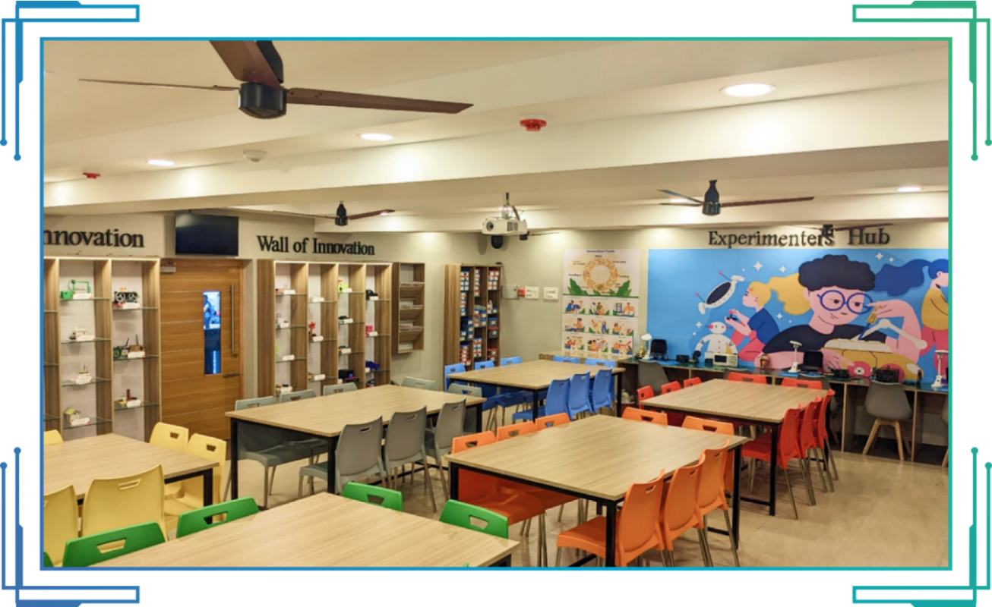
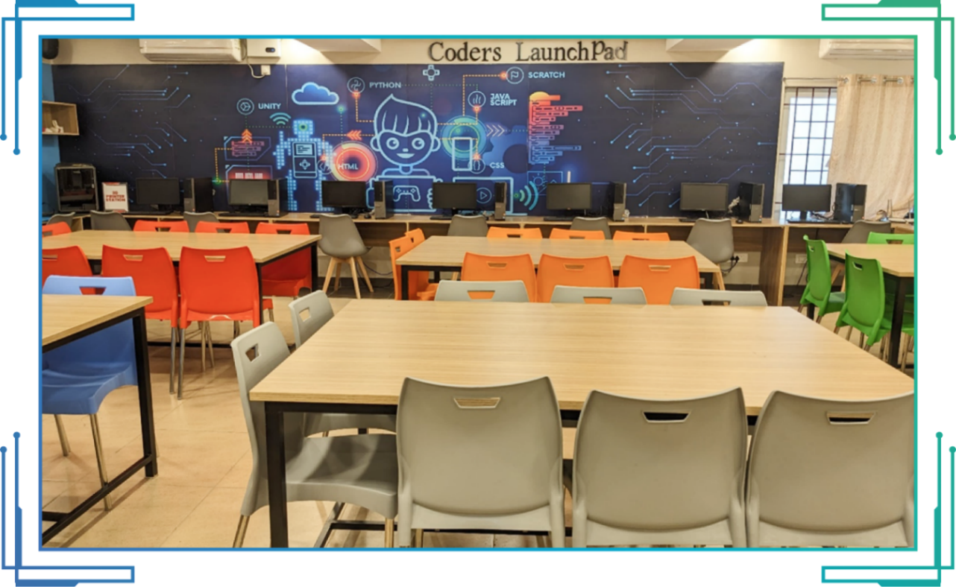

Note: The photos shown below are for reference only. The actual design, look and feel of the lab will depend on the space and interiors provided by the school.

Innovation Lab Setup Details

Lab Elements | Specifications | Descriptions
Laptops | Number: <ask:6 Units> | Yes
Tables | <ask:4 Units> | Yes
Chairs | <ask:30 Units> | Yes
AR/VR Zone | Students can experience AR/VR technology using the Oculus headsets (2 units) | Yes
3D Print Zone | <ask:1 3D Printer with filaments> | Yes
Wall of Innovation | <ask:3 Nos> | Yes
Innovation Milestone Wall | A wall displaying the ongoing progress of IBC, providing visibility to all visitors | Yes
MeasureUp Wall | Students can use a sensor-based device attached to the wall to accurately measure their height and weight | Yes
Experimenters Hub <ask:(3 Nos)> | CRO, Safety Glass <ask: (10 units)>, Drill Machine, Soldering Station <ask: (3 units)>, Exhaust Fan <ask:(3 Nos)>, Hot Air Blower, Screwdriver Sets, Spanner Set, L and Key Set, Glue Guns <ask:(2 Nos)> | Yes
Coders Launchpad | A dedicated area for students to engage in coding activities using laptops or desktops | Yes
Green and White Board | Instructors will be provided with a green and white whiteboard for use during class | Yes
Sensor-equipped Lab | Fire Detector, Motion Sensor for lighting, Noise Level Sensor, Smoke Detector, Smart Curtain, Smart Fans, etc. | Yes
Student Attendance with Face Detection | Students can use the app to mark attendance at the Innovation Lab | No
32-inch Display | For displaying upcoming events, news and advertisements | Yes
Electronic Components (100 Components – Each component of 50 Nos) | Example: Resistors, LEDs, Connector cables, Breadboards, DC Motors, Capacitor, Diodes, Transistors, Buzzers, Multimeters, etc. | Yes
Programmable Boards | Arduino <ask:(50 Nos)>, Raspberry Pi <ask:(5 Nos)> | Yes
Analog and Digital Sensors (10 Types each – 50 Nos) | Ultrasonic, IR, LDR, Temperature Sensor, etc | Yes
Component Organisers | <ask:4 Units> | Yes
Magazine Rack | <ask:1 Unit> | Yes
Projector | <ask:1 Unit> | Yes
Audio and Mic System | <ask:1 Unit> | Yes
Safety Equipment | Fire Extinguisher: <ask:1> | No
First Aid Box: | <ask:1 Unit> | Yes

Pricing Overview

Description | Estimation
YuviPep Futuristic Innovation Lab (YFIL) | <ask_calculate:Rs. 15,00,000/- to Rs. 25,00,000/-net (including GST)>
Note:
- The pricing range depends on the specific equipment and tools the school selects for the lab.
- Costs will vary based on the chosen items, and final pricing will be adjusted accordingly.
- Pricing will vary depending on customisation and size requirements. The above estimation is for approximately 750 sq. ft.
- A detailed pricing breakdown will be provided after evaluating the available space and understanding the school's specific requirements.



Contact Details
<Ph no. yuvipep>
<email yuvip>
<website yuv>

<Address yuvipep>

